Lab 3. Exception Handling and Dynamic SQL

**3.1: Modify the programs created in Lab2 to implement Exception Handling**

**INPUT:**

DECLARE

CURSOR C_staff IS

SELECT Staff_Code,Staff_Name,Staff_Sal FROM Staff_Master WHERE Dept_Code=&Dept_Code;

myvar C_staff%ROWTYPE;

cnt Number:=0;

No_rec_ret EXCEPTION;

BEGIN

OPEN C_staff;

LOOP

FETCH C_staff INTO myvar;

IF C_staff%FOUND THEN

cnt:=cnt+1;

DBMS_OUTPUT.PUT_LINE(myvar.Staff_Code||' '||myvar.Staff_Name||' '||myvar.Staff_Sal);

ELSE

EXIT;

END IF;

END LOOP;

IF cnt=0 THEN

RAISE No_rec_ret;

END IF;

EXCEPTION

WHEN No_rec_ret THEN

DBMS_OUTPUT.PUT_LINE('No record found.');

CLOSE C_Staff;

END;

/

**OUTPUT:**

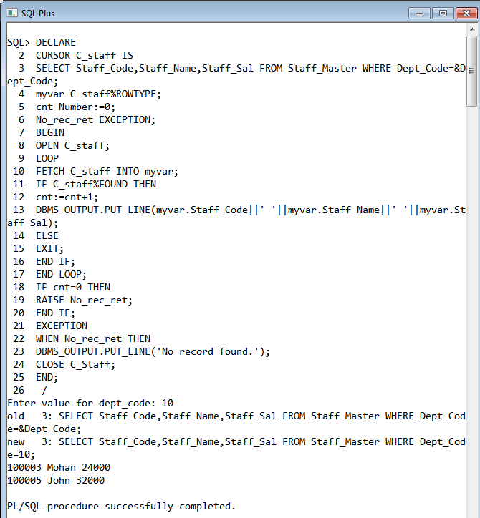

**3.2 The following PL/SQL block attempts to calculate bonus of staff for a given**

**MGR_CODE. Bonus is to be considered as twice of salary. Though Exception Handling**

**has been implemented but block is unable to handle the same.**

**Debug and verify the current behavior to trace the problem.**

DECLARE

V_BONUS V_SAL%TYPE;

V_SAL STAFF_MASTER.STAFF_SAL%TYPE;

BEGIN

SELECT STAFF_SAL INTO V_SAL

FROM STAFF_MASTER

WHERE MGR_CODE=100006;

V_BONUS:=2*V_SAL;

DBMS_OUTPUT.PUT_LINE('STAFF SALARY IS ' || V_SAL);

DBMS_OUTPUT.PUT_LINE('STAFF BONUS IS ' || V_BONUS);

EXCEPTION

WHEN NO_DATA_FOUND THEN

DBMS_OUTPUT.PUT_LINE('GIVEN CODE IS NOT VALID.ENTER VALID CODE');

END;

**INPUT:**

DECLARE

V_BONUS V_SAL%TYPE;

V_SAL STAFF_MASTER.STAFF_SAL%TYPE;

BEGIN

SELECT STAFF_SAL INTO V_SAL

FROM STAFF_MASTER

WHERE MGR_CODE=100006;

V_BONUS:=2*V_SAL;

DBMS_OUTPUT.PUT_LINE('STAFF SALARY IS ' || V_SAL);

DBMS_OUTPUT.PUT_LINE('STAFF BONUS IS ' || V_BONUS);

EXCEPTION

WHEN NO_DATA_FOUND THEN

DBMS_OUTPUT.PUT_LINE('GIVEN CODE IS NOT VALID.ENTER VALID CODE');

END;

/

**OUTPUT:**

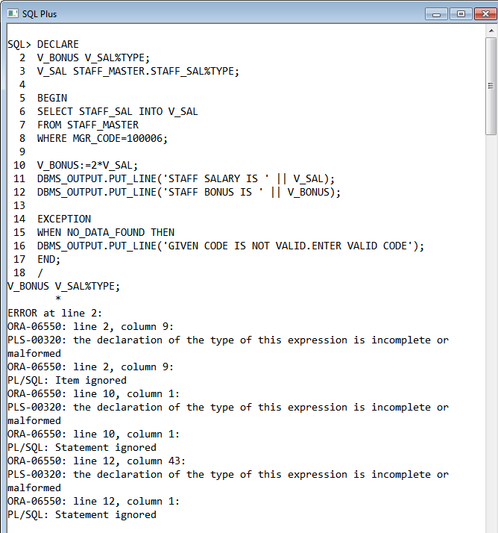

**3.3 Rewrite the above block to achieve the requirement.**

**INPUT:**

DECLARE

V_SAL STAFF_MASTER.STAFF_SAL%TYPE;

V_BONUS V_SAL%TYPE;

BEGIN

SELECT distinct STAFF_SAL INTO V_SAL FROM STAFF_MASTER WHERE MGR_CODE=100006;

V_BONUS:=2*V_SAL;

DBMS_OUTPUT.PUT_LINE('STAFF SALARY IS ' || V_SAL);

DBMS_OUTPUT.PUT_LINE('STAFF BONUS IS ' || V_BONUS);

EXCEPTION

WHEN NO_DATA_FOUND THEN

DBMS_OUTPUT.PUT_LINE('GIVEN CODE IS NOT VALID.ENTER VALID CODE');

WHEN OTHERS THEN

DBMS_OUTPUT.PUT_LINE('MULTIPLE ENTRIES WITH 100006 AS MANAGER');

END;

**OUTPUT:**

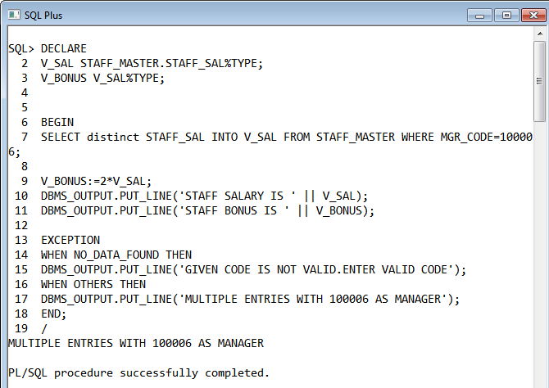

**3.4 Predict the output of the following block ? What corrections would be needed to make it**

**more efficient?**

BEGIN

DECLARE

fname emp.ename%TYPE;

BEGIN

SELECT ename INTO fname

FROM emp

WHERE 1=2;

DBMS_OUTPUT.PUT_LINE('This statement will print');

EXCEPTION

WHEN OTHERS THEN

DBMS_OUTPUT.PUT_LINE('Some inner block error');

END;

EXCEPTION

WHEN NO_DATA_FOUND THEN

DBMS_OUTPUT.PUT_LINE('No data found in fname');

WHEN OTHERS THEN

DBMS_OUTPUT.PUT_LINE('Some outer block error');

END;

**INPUT:**

BEGIN

DECLARE

fname emp.ename%TYPE;

BEGIN

DBMS_OUTPUT.PUT_LINE('This statement will print');

SELECT ename INTO fname

FROM emp

WHERE 1=2;

EXCEPTION

WHEN OTHERS THEN

DBMS_OUTPUT.PUT_LINE('Some inner block error');

END;

EXCEPTION

WHEN NO_DATA_FOUND THEN

DBMS_OUTPUT.PUT_LINE('No data found in fname');

WHEN OTHERS THEN

DBMS_OUTPUT.PUT_LINE('Some outer block error');

END;

**OUTPUT:**

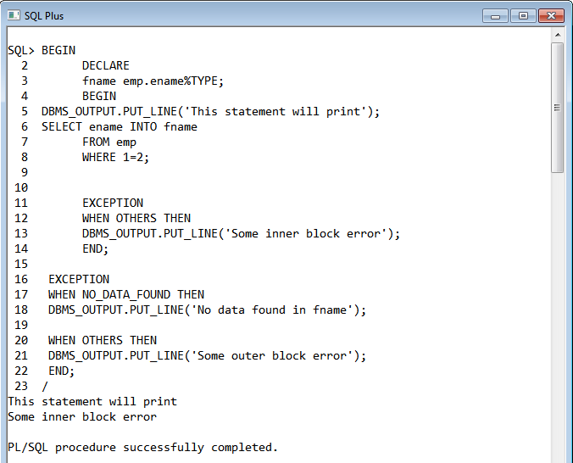

**3.5 Debug the above block to trace the flow of control. Additionally one can make appropriate changes in Select statement defined in the block to check the flow.**

**INPUT:**

BEGIN

DECLARE

fname emp.ename%TYPE;

BEGIN

DBMS_OUTPUT.PUT_LINE('This statement will print');

SELECT ename INTO fname

FROM emp

WHERE empno=&empno;

DBMS_OUTPUT.PUT_LINE('This statement will print');

EXCEPTION

WHEN OTHERS THEN

DBMS_OUTPUT.PUT_LINE('Some inner block error');

END;

EXCEPTION

WHEN NO_DATA_FOUND THEN

DBMS_OUTPUT.PUT_LINE('No data found in fname');

WHEN OTHERS THEN

DBMS_OUTPUT.PUT_LINE('Some outer block error');

END;

/

**OUTPUT:**

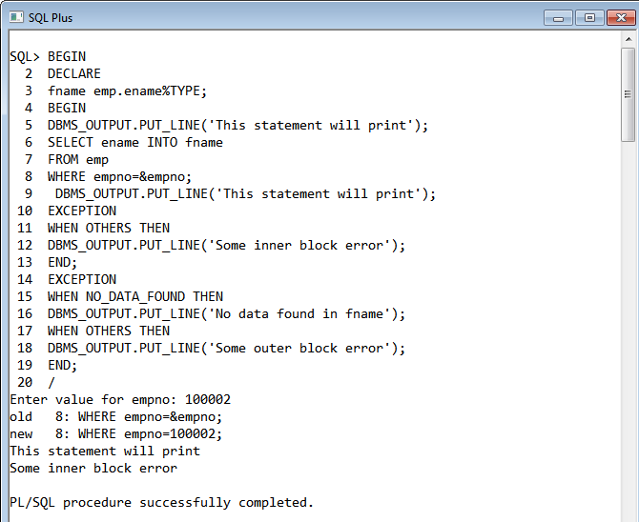

**3.6: Write a PL/SQL program to check for the commission for an employee no 7369. If no**

**commission exists, then display the error message. Use Exceptions.**

**INPUT:**

DECLARE

MYEXCEPTION EXCEPTION ;

commission emp.ename%TYPE;

BEGIN

SELECT comm INTO commission

FROM emp

WHERE empno=7369;

if trim(commission) is NULL then

raise MYEXCEPTION;

else

dbms_output.put_line('Commission for employee 7369 is '||' '||commission);

end if;

EXCEPTION

WHEN NO_DATA_FOUND THEN

DBMS_OUTPUT.PUT_LINE('No data found in fname');

WHEN MYEXCEPTION THEN

DBMS_OUTPUT.PUT_LINE('No commission');

END;

**OUTPUT:**

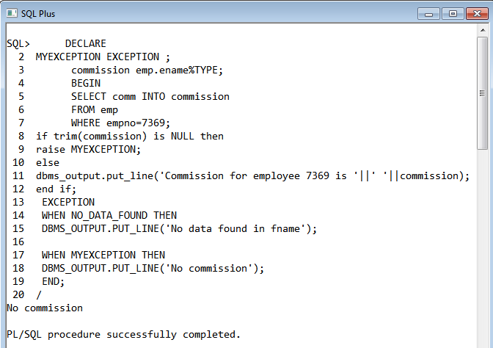

**3.7: Write a PL/SQL block to drop any user defined table.**

**INPUT:**

BEGIN

execute immediate 'DROP TABLE &name' ;

END;

/

**OUTPUT:**

